Experiment Details

|  |  |
| --- | --- |
| Department Name | Electrical Dept |
| Class | S.Y.B.tech |
| Semester | III |
| Subject Name | Analog Electronics |
| Experiment No. | 1 |
| Experiment Name | Half Wave Rectifier with Capacitor Filter. |

Version History

|  |  |  |  |  |
| --- | --- | --- | --- | --- |
| Sr. No. | Version Number | Created By | Approved By | Date |
| 1 | v1.0 | Priya Yadav | Mrs. Sushmita Sharma | 13/10/2020 |
|  |  |  |  |  |

AIM:

To Study of Half wave rectifier with capacitor filter.

THEORY:

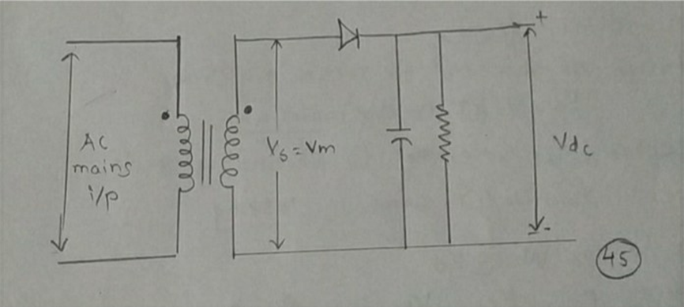

**Fig.(a) Half wave rectifier with capacitor filter**

Half wave rectifier with capacitor connected across the load as shown in fig.(a). The operation of this type of filter depends on the fact that a capacitor, stores energy and tries to maintain the same. The capacitor charges to peak value of input voltage, Vm, & discharges through RL until the input voltage reaches back to value greater than capacitor value voltage. Thus the diode will conduct for a short period & recharges the capacitor.

**Analysis:-**

***i)Ripple Factor:-***

By definition of ripple factor

r=Vrrms/Vdc ___________(1)

But the rms voltage is

Vrrms= Vrpp/2√3 ___________(2)

The ripple voltage Vrpp can be calculated under steady state condition of the capacitor voltage i.e.

**Charging =Discharging** ___________(3)

The average value of load current Idc is the average value of the capacitor discharge current interval of T2. The amount of charge lost during this interval is,

Qdischarge = Idc × T2 ___________(4)

The interval T1during which voltage across the capacitor changes by an amount Vrpp. Hence the charge supplied to capacitor is

Qcharge = Vrpp × C ___________(5)

From eqn (3) Idc × T2= Vrpp × C

Vrpp = (Idc × T2) / C ___________(6)

Now let assume the load is light, the ripple is small and the time for recharging the capacitor is small as compared with time for which it discharges. In other words,

T1<< T2 and T2 ≈ T=1/f ___________(7)

Then **Vrpp = Idc / (C×f)**  ___________(8)

Thus, rms value of ripple voltage from eqn(2) is

**Vrrms = Idc / (2√3 C×f)** ___________(9)

The ripple factor is **r = Vdc / (2√3 C×f×RL×Vdc)**

**r = 1 / (2√3 C×f×RL)** ___________(10)

Thus, the ripple factor may be decreased by increased C or RL (or both) with resulting increase in dc output voltage.

***r = 5774/(C×RL)*** *for f = 50Hz*

***ii)Average dc Output Voltage:-***

If the total capacitor discharge voltage is Vrpp in the interval T2, than average dc voltage is,

Vdc = Vm – Vrpp/2 ___________(11)

But Vrpp = Idc / (C×f) and Idc = Vdc / RL

Therefore Vdc = Vm – Idc / (2f×C)

Now f = 50Hz & C in µf & RL in Ω then

**Vdc = Vm – 10000×Idc / C**  ___________(12)

***iii)Voltage Regulation:-***

A degree to which power supply varies in output voltage under the conditions of load variations is measured by voltage regulation. It is expressed as,

% Voltage regulation = (VNL – VFL)×100 / VFL

Now VFL= Vdc = Vm – 10000×Idc / C

VNL= Vm/ π

PRE TEST:

1. When the capacitor gets charge upto peak value of input voltage it discharges through
2. **RL**
3. Output voltage
4. Vm

1. When can ripple factor be calculated
2. **At steady state**
3. At unstable state
4. None of these
5. How can ripple factor be decreased
6. Decrease RL
7. Decrease C
8. **Increase RL or C**
9. Decrease RL and increase C

1. If the total capacitor discharge voltage is Vrpp in the interval T2, than average dc voltage is,
2. Vdc = Vm – Vrpp/2
3. **Vdc = Vm – Idc / (2f×C)**
4. Vdc = Vm – 10000×Idc / C
5. Vdc= Idc- Vm

PROCEDURE:

1. Connect the half wave circuit as per circuit diagram on breadboard.
2. Connect P-N junction diode in series with load resistance RL.
3. Connect channel-X to input and channel –Y to output of rectifier and observe the waveform on CRO screen & draw the waveform on graph.
4. From w/f note done corresponding reading of Vm, Vdc, Vrpp & Idc.
5. For voltage regulation, remove the load & measure & observe the voltage on CRO screen.

**Observation Table:-**

|  |  |  |  |  |  |  |
| --- | --- | --- | --- | --- | --- | --- |
| **Sr. No.** | **Para-meter** | **Observed Value** | **Calculated Value** | **Sr. No.** | **Para-meter** | **Observed Value** |
| **01** | **Vm** |  |  | **07** | **%V.R.** |  |
| **02** | **Vrpp** |  |  | **08** | **Tline** |  |
| **03** | **Vdc=VFL** |  |  | **09** | **Tchar** |  |
| **04** | **Idc** |  |  | **10** | **Tdischar** |  |
| **05** | **R.F.** |  |  | **11** | **Ttotal=Tchar+Tdischar** |  |
| **06** | **VNL** |  |  |  |  |  |

**Calculations:-**

1. **Vdc = Idc×RL**

**=____________**

**=____________**

1. **Vm = Vdc+ 10000×Idc / C**

**=____________________**

**=_____________**

1. **R.F.(Cal) = r = 5774/(C×RL)**

**=____________________**

**=______________**

1. **R.F.(Obs) = r = Vrpp/(2√3×Vdc)**

**=____________________**

**=______________**

1. **Vrpp= Idc/(f×C)**

**=___________________**

**=_______________**

1. **% Voltage regulation = (VNL – VFL)×100 / VFL**

**=_______________________**

**=______________**

1. **Tline=______________=_____________**
2. **Tchar=______________=____________**
3. **Tdischar=_______________=_____________**
4. **Ttotal=Tchar+Tdischar=______________=____________**

POST TEST:

1. The basic purpose of filter is to
   1. minimize variations in ac input signal
   2. suppress harmonics in rectified output
   3. **remove ripples from the rectified output**
   4. stabilize dc output voltage
2. The use of capacitor filter in rectifier circuit gives satisfactory performance only when the load

a) current is high

b) **current is low**

c) voltage is high

d) voltage is low

3) In the exp what is the formula for calculation of R.F

a) **5774/(C×RL)**

b)Vrpp/(2√3×Vdc)

4) A capacitor filter or C filter can be used in a rectifier by connecting it  
 a**) in parallel with the load**  
 b) in series with the load  
 c) in parallel with the supply  
 d) in series with the supply

CONCLUSION:

From graph it is seen that output of HWR with capacitor filter is

approximate triangular waveform and time required for discharge of capacitor (T2) is approximately total period of cycle (T) i.e.___________.

From above experiment we conclude that by designing proper values

of components we get design specification.